**SQL Server 2016 Pre-Upgrade Checklist & Unsupported Scenarios**

<https://www.gigxp.com/sql-server-2016-pre-upgrade-checklist-and-unsupported-scenarios/>

Before upgrading to the newest version of SQL Server, you would ideally need to ensure that the transition is smooth. You can check out our SQL Server 2016 Pre-Upgrade Checklist to know more about the upgrade paths. Read along to know more.

## SQL Server 2016 Pre-Upgrade Checklist

[SQL Server 2016](https://www.gigxp.com/new-sql-server-2016-installation-features-walk-through/) introduced a significant number of [enhancements](https://www.gigxp.com/sql-server-2016-new-features/) and [feature](https://www.gigxp.com/sql-server-2016-security-features/) releases, which have prompted corporations to envision for an upgrade.

For a successful upgrade and migration path to SQL Server 2016, you need to ensure that you have followed all the SQL server 2016 pre-upgrade [checklist](https://www.gigxp.com/sql-server-failover-cluster-checklist/) and unsupported scenarios.

Firstly, you need to make sure that your edition of SQL Server is eligible for a direct upgrade path to SQL Server 2016. You can upgrade to SQL Server 2016 from the following versions:

* SQL Server 2008
* SQL Server 2008 R2
* SQL Server 2012
* SQL Server 2014

### Check your SQL Server Edition to see if you have a direct upgrade path:

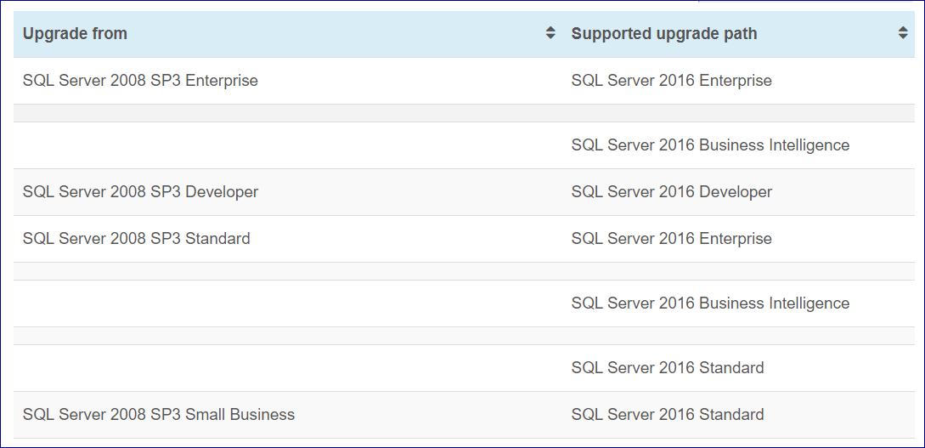



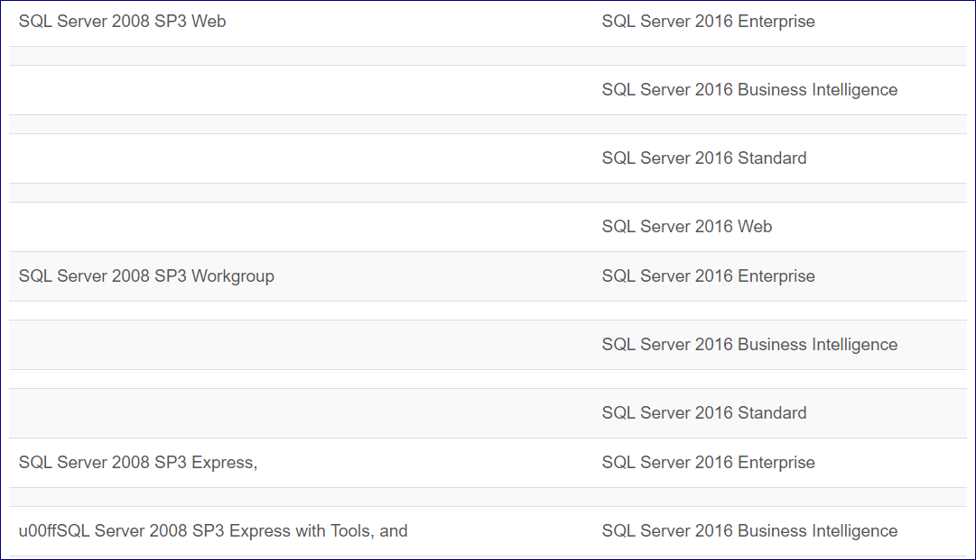



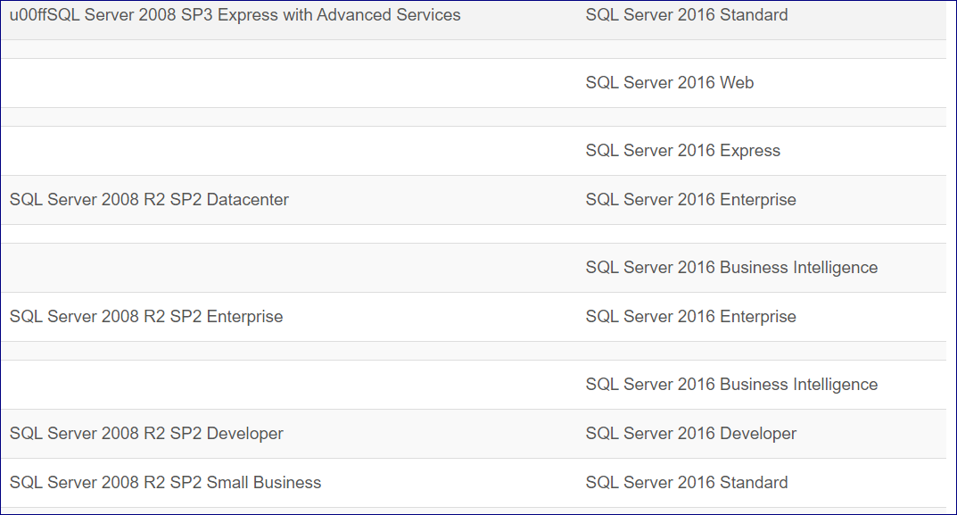



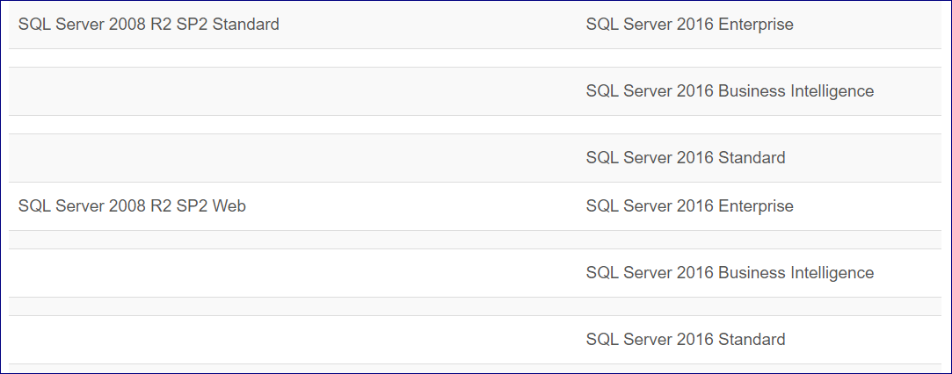

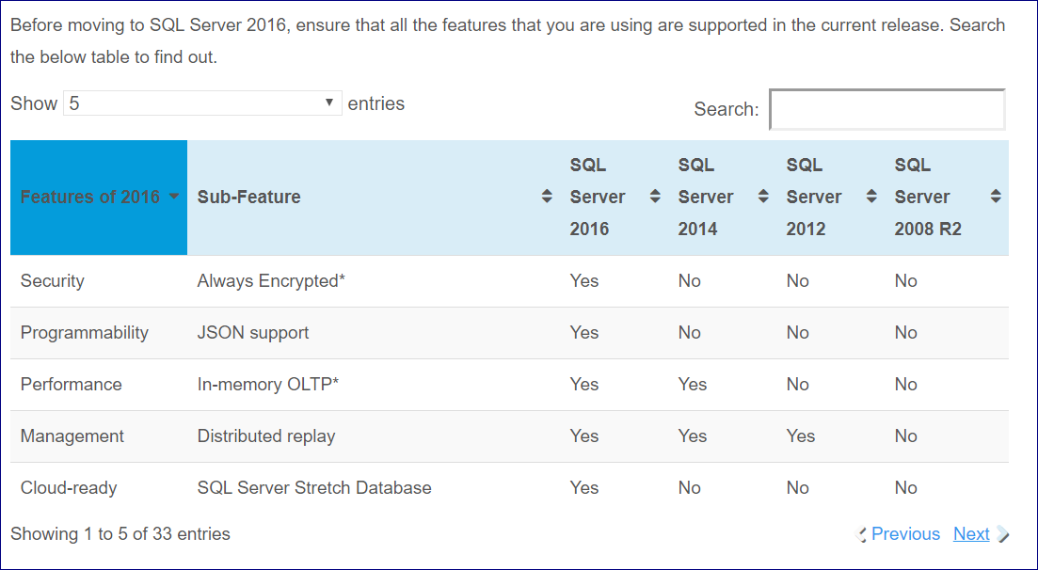

### **Current Limitations and Unsupported Scenarios**

* All the SQL Server components must have the same version numbers. You cannot use different [build numbers](https://www.gigxp.com/list-of-sql-server-versions-build-numbers-and-service-packs/) for Reporting, Analysis, Integration or Database Services. They all need to have the same version numbers.
* Upgrade from 32 Bit to 64 Bit in-place upgrade is not supported. You need to do a side by side upgrade to a 64 Bit instance since both backup-restore or detach-attach is fully supported.
* Cannot add additional feature during the in-place upgrade process. Newer features can only be added after the upgrade is complete.
* 32-bit Fail-over Clusters are not supported for a direct upgrade to SQL 2016.
* Evaluation versions need to be upgraded to a [licensed](https://www.gigxp.com/sql-server-2014-core-licensing/)edition before upgrading to SQL Server 2016.
* Evaluation versions cannot be upgraded to a clustered installation. Only standalone versions are supported.
* 64 Bit Editions of earlier versions can only be upgraded to a 64 bit SQL Server 2016 Edition.
* SQL Server 2005 can only be restored with compatibility level 100 and above.
* Changing of Editions of [SQL Clusters](https://www.gigxp.com/sql-server-failover-clustering-high-availability/) in 2016 is not supported.